$10,000 or above with a grant purpose that is program or project specific.

You are not required to submit a report if your grant is:
- below $10,000, regardless of purpose, (or)
- above $10,000 with a grant purpose of General Operating Support

Organization Name
Grant (Distribution) ID
 | You may use one form for multiple distributions of the same purpose
Fund Name (if available)
Grant Amount
Grant Purpose
(Per award letter)
Report Prepared by  Name |  | Date
Title
Email |  | Phone

Please type directly on this form, save as a pdf, and email it to GrantsMgmt@clevefdn.org along with any supporting materials or a current annual report.

Expenditure of Grant Funds
Funds must be used in accordance with the authorized purpose. Any funds not expended for the purpose agreed to by the grantee, must be returned to the Cleveland Foundation.

- How have the grant funds been used?
Click here to enter text.

- What impact did these grant funds have on your organization?
Click here to enter text.

- What were the principal accomplishments of your organization this year?
Click here to enter text.

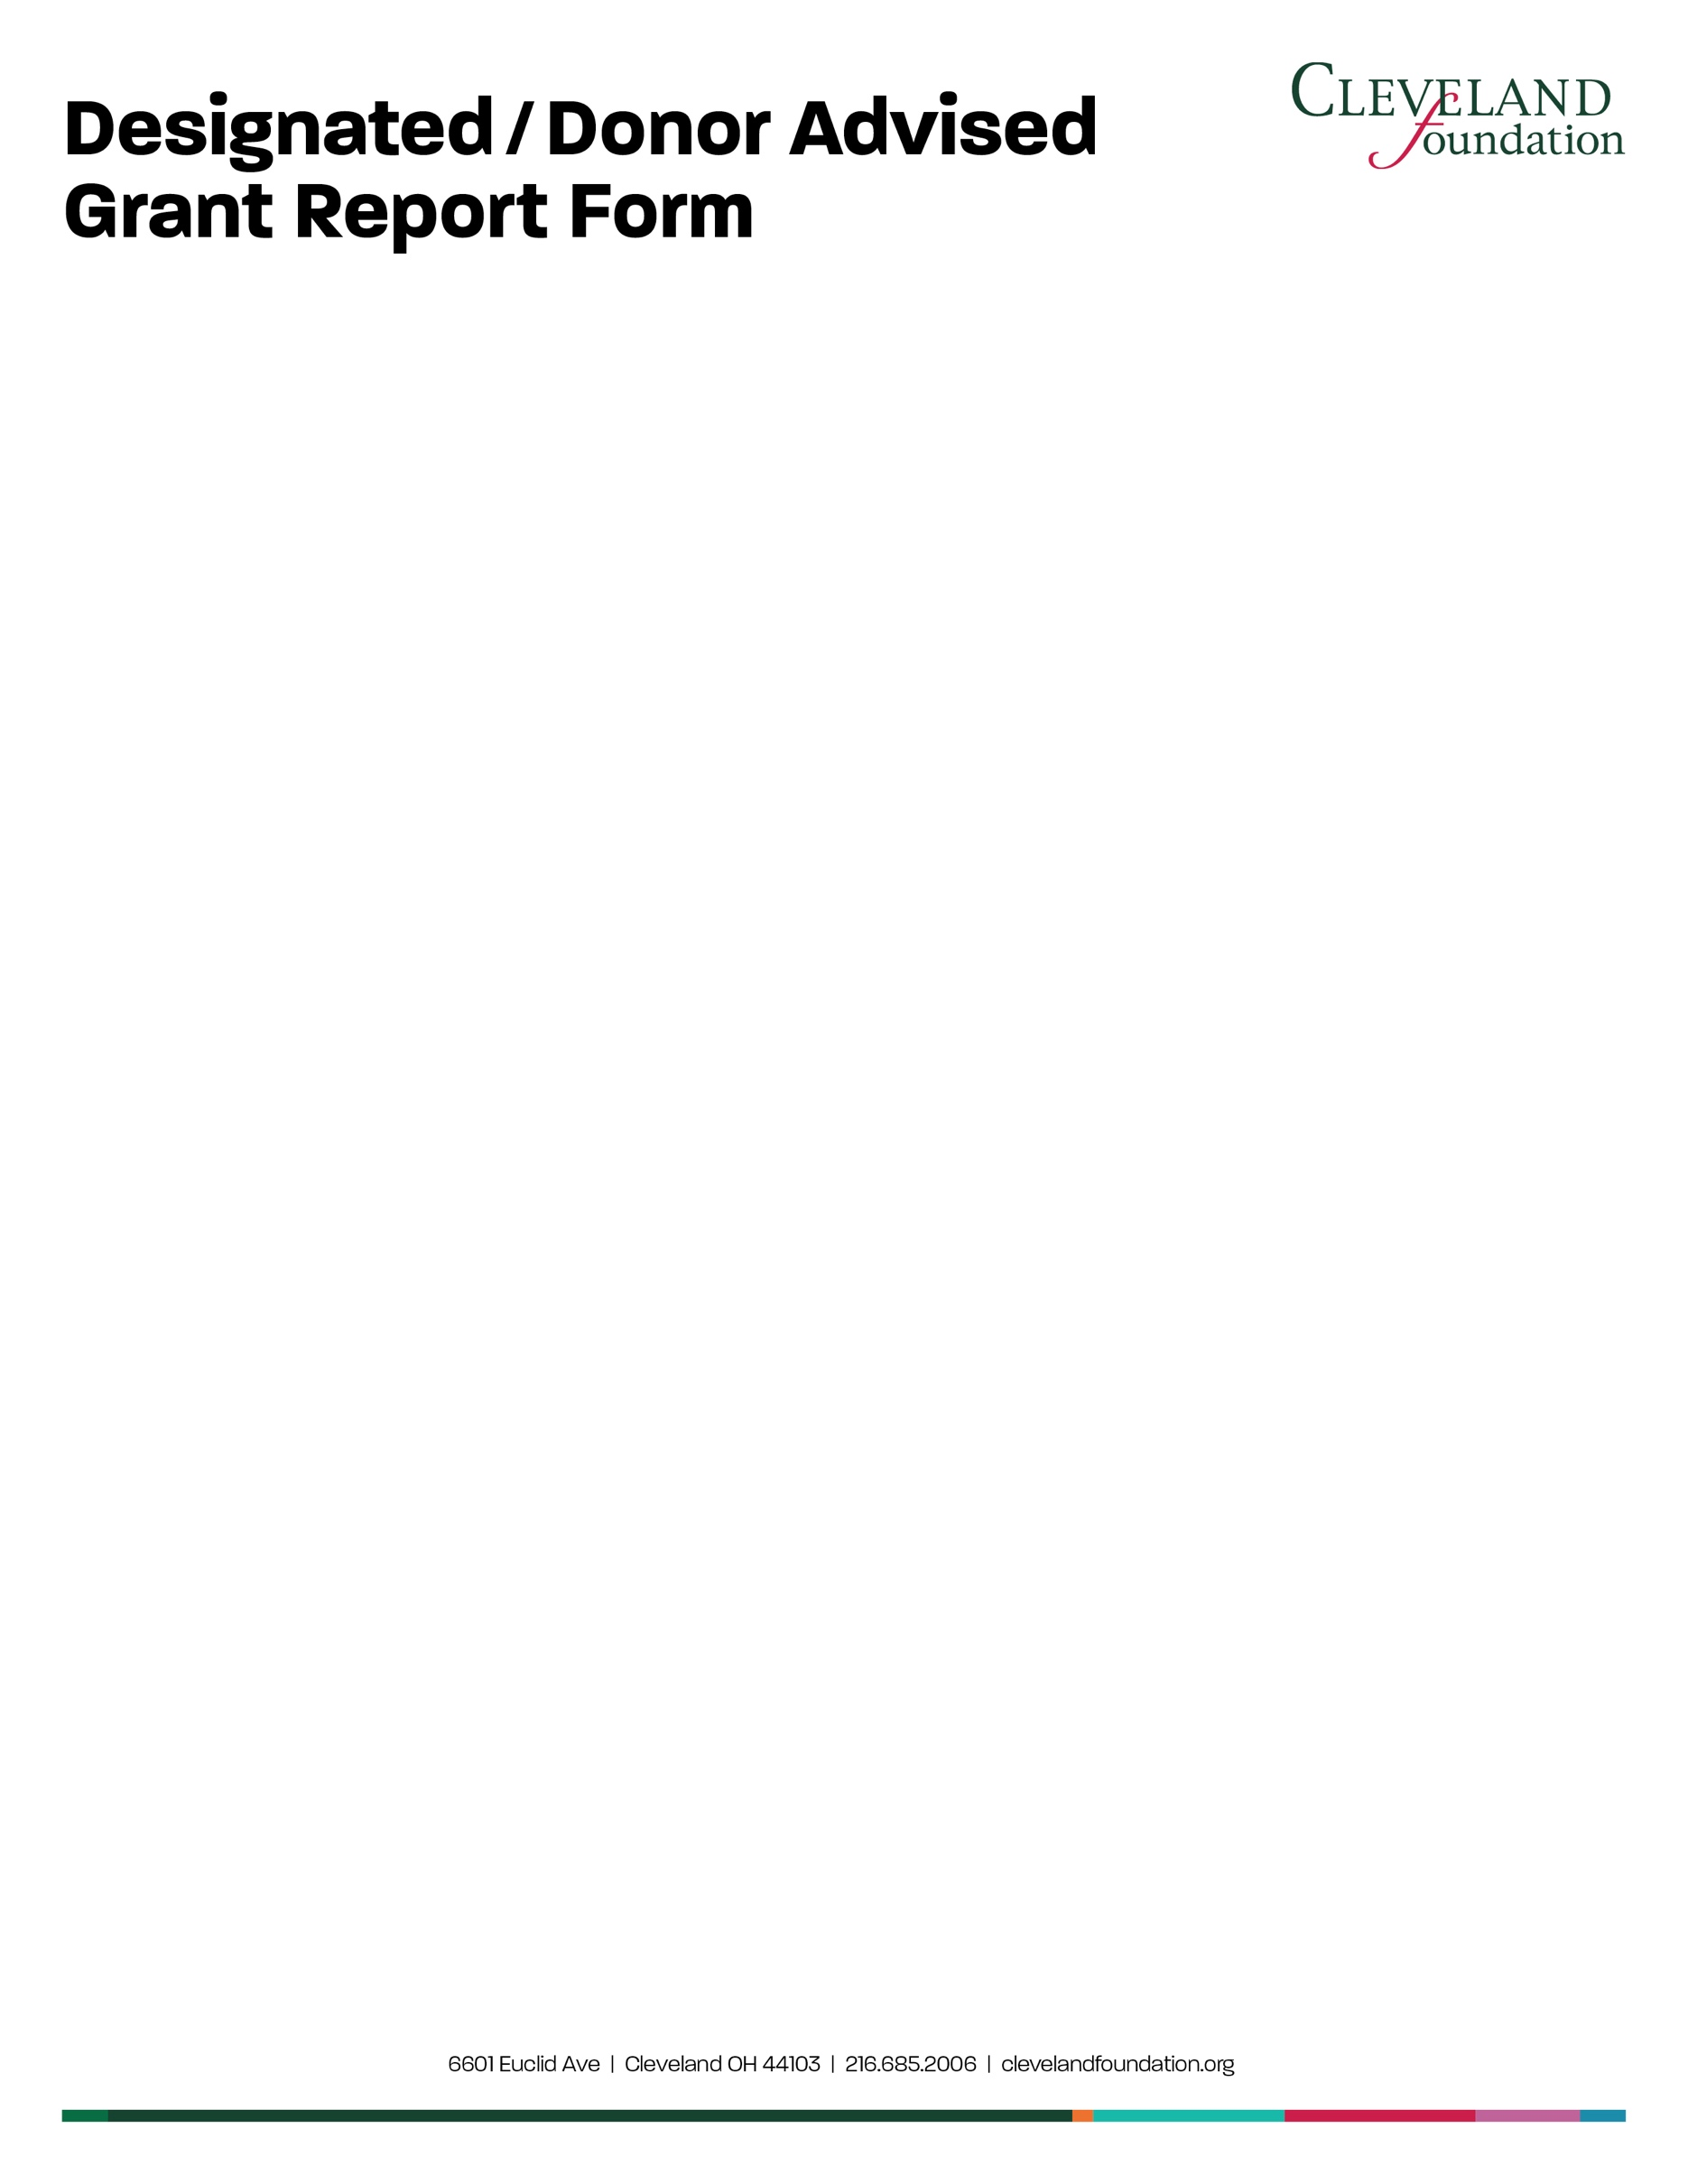

II. Organizational Information
It is very helpful to understand the organizational context in which you are using grant funds.
Please take this opportunity to update us on any significant organizational changes, developments,
or challenges. How have these developments contributed to or impeded organizational success?
Click here to enter text.

